NOTES

* Raspberry Pi is a cheaper alternative to a PC and is being widely received in schools in UK for teaching programming
* In October 2012 the Raspberry Pi won T3's "Innovation of the Year" award
* **Official programming language is Python but also supports Java**

Image:

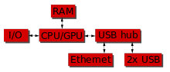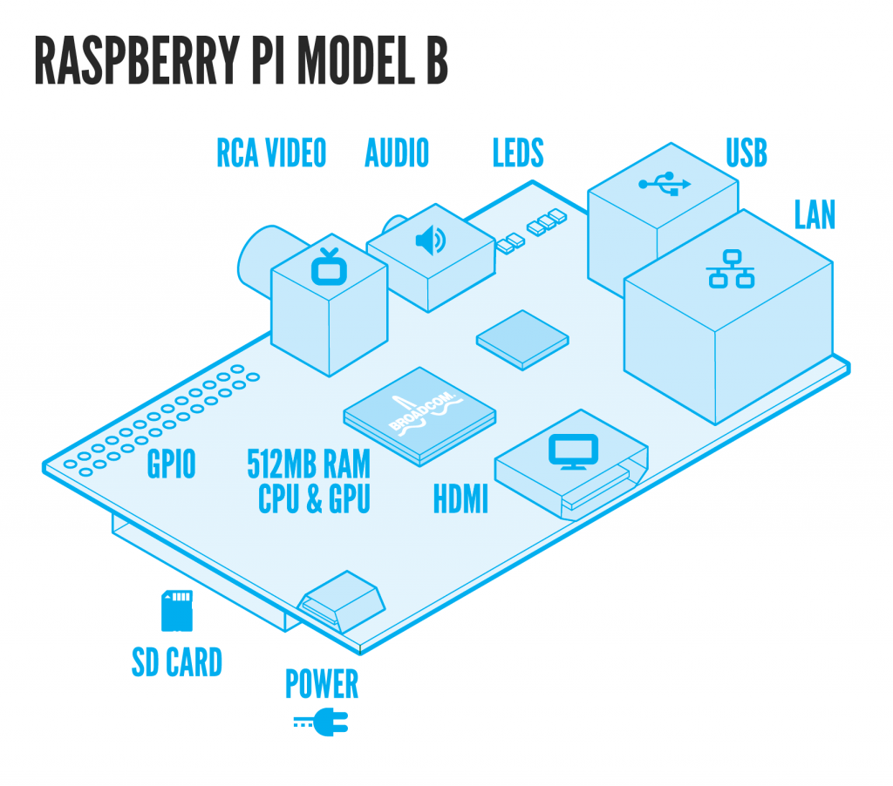

Reference: <http://elinux.org/RPi_Low-level_peripherals#Java>

**Raspbian** : Linux kernel OS

GPIO:

* a generic pin on a chip whose behavior can be controlled (programmed) through software
* 2x13 header pins
* GPIO voltage levels are 3.3 V and are not 5 V tolerant. There is no over-voltage protection on the board
* Each GPIO can interrupt, high/low/rise/fall/change. The 'Raspbian "wheezy" version that is currently recommended for starters already includes GPIO interrupts.
* <http://pi4j.com/> : **java library for GPIO connection**

The Pi4J library includes support for:

* GPIO Control
* GPIO Listeners
* Serial Communication
* I2C Communication
* SPI Communication

Equipment Quote:

* Raspberry Pi Model B
* £32.88(£27.40 exc. VAT) with 8GB SD card with pre-installed Raspian OS <http://raspberrypi.rsdelivers.com/default.aspx?cl=1>
* USB keyboard, mouse
* TV or monitor (with HDMI, DVI, Composite or SCART input)
* USB WiFi adaptor or LAN (Ethernet) cable (optional)
* Powered USB hub (optional)